Process to import .csv document into MongoDB Compass collection.

*If the backend API is unable to get setup, we will only be able to process 500 queries/hour, half of the 1000queries/hour but can be scaled with paying a bit more.

MongoDB Information:
- Database name: FreshTime LDB
- Collection name: LC

- Download MongoDB Database Tools here.
- Need to utilize mongoimport command, find this by:
  - Visiting mongodb.com, log in with account information.
  - In the Deployment > Database tab, click on the cluster name (below, it is Cluster0):
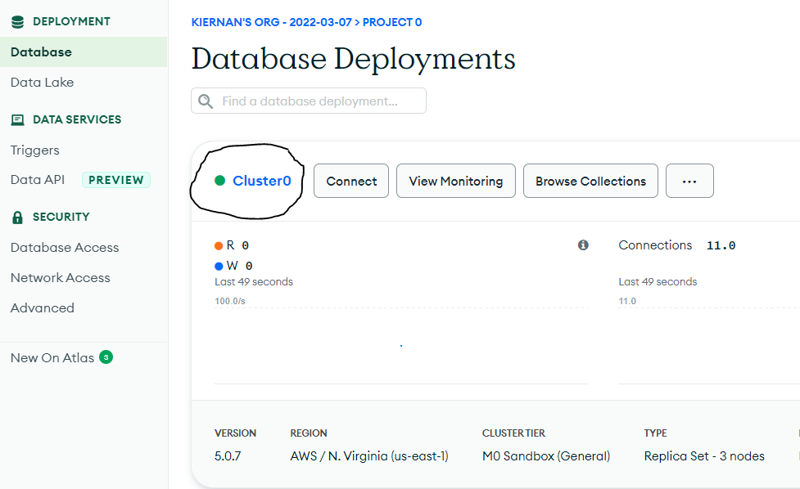
- Next, click on the ‘Cmd Line Tools’ tab below:
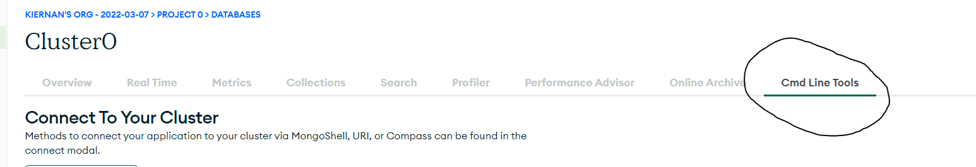
- Scroll down to the ‘Data Import and Export Tools’, and copy the mongoimport command. Replace fields with <> around them with correct fields.
  - Base Case:
    - mongoimport --uri mongodb+srv://ecko:<PASSWORD>@cluster0.fp474.mongodb.net/<DATABASE> --collection <COLLECTION> --type <FILETYPE> --file <FILENAME>
  - Our Case:
    - mongoimport --uri mongodb+srv://ecko:<PASSWORD>@cluster0.fp474.mongodb.net/FreshTimeLDB --collection LC --type csv --file C:\Users\Kiernan\Downloads\MongoDBFormatDatasheet.csv --headerline
    - *Replace <PASSWORD> with the MongoDB Account default password, not the admin password.
      - i.e. <PASSWORD> becomes ‘example123’ instead of ‘<example123>’
- Launch instance of command prompt, navigate to install directory.
  - cd C:\Program Files\MongoDB\Tools\100\bin
- Run the command above, and it should successfully import data, as seen below.
